

**Fee Payment Module**

* Vision

Automate the existing fee payment process and onboard it onto a subscription based framework.

* Technologies

Html, CSS, Javascript, PHP, MySql

* Concept

Web Technology, Database Management, Data Warehousing, Payment Gateway, Full Stack Development

* Workflow

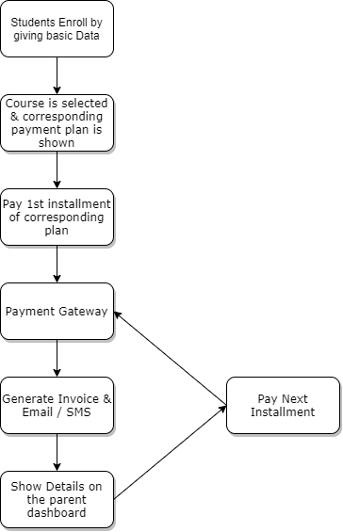

* Components

1. Enrollment Page
2. Courses & Fee Structure Page
3. Payment Page
4. Payment Gateway Engine & Page
5. Invoice Generating Engine & Page
6. Parent Dashboard

**Student Resources**

* Vision

Provide all study material required for the 11th & 12th Science students in digital format all in one place.

* Technologies

Html, CSS, Javascript, PHP, MySql

* Concept

Web Technology, Database Management, Data Warehousing, Payment Gateway, Full Stack Development

* Workflow

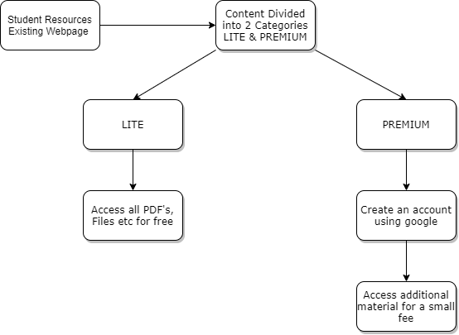

* Components

1. Student Resources Page (70% Developed)
2. LITE & PREMIUM Content Segregation
3. Account Generation
4. Payment Gateway Integration

Reporting Manager

Prof. Gaffney Mendonsa

Team

1. Jaimin Solanki
2. Alvin Solomon
3. Rohan Tondlekar
4. Keegan Vaz

Project Duration

5-6 Months